12.88: As suggested in the problem, divide the disk into rings of radius r and thickness dr. Each ring has an area 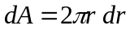and mass 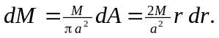 The magnitude of the force that this small ring exerts on the mass m is then 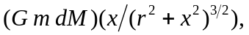 the expression found in Problem 12.82, with dM instead of M and the variable r instead of a. Thus, the contribution dF to the force is 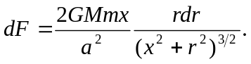
The total force F is then the integral over the range of r;
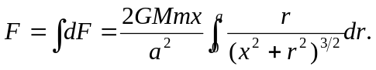
The integral (either by looking in a table or making the substitution 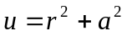) is
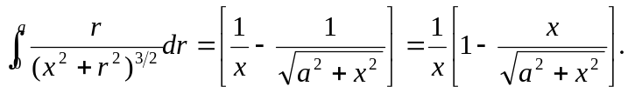
Substitution yields the result
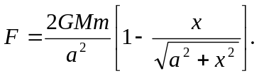

The second term in brackets can be written as
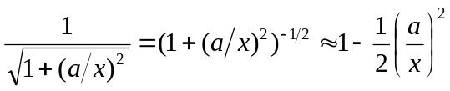
if x >> a, where the binomial approximation (or first-order Taylor series expansion) has been used. Substitution of this into the above form gives

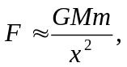
as it should.

